

**UNIVERSITY OF PETROLEUM & ENERGY STUDIES**

**Dehradun ACO LAB**

**Name-Ritik Kumar**

**Batch- 4 DEVOPS**

**SAP ID- 500097106**

**Roll No- R2142211330**

**SUBMITTED TO- Dr. Hitesh Kumar Sharma**

**Experiment – 8**

**AIM : Creating Service in Kubernetes**

# Task 1: Start Kubernetes in Docker-Desktop

• Start Kubernetes service in Docker-Desktop

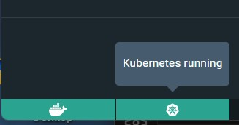

# Task 2: Creating a Service

Create a service to expose the deployed application within the Kubernetes cluster. You can use the following sample YAML manifest as a reference:

apiVersion: V1 kind: Service metadata:

name: my-service spec:

selector:

app: lbnginx ports:

- protocol: TCP port: 80

nodePort: 30001

type: NodePort

• Apply the service using the following command:

# “ kubectl apply -f service.yaml ”



• Verify that the service is created by running the following command:

**“kubectl get services”**

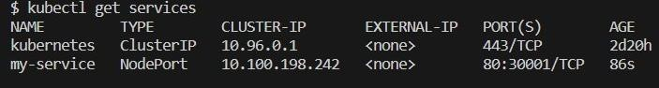

# Task 3: Accessing the Service

* Access the service using port forwarding. Run the following command:
* Access the Nginx server running in the service by opening a web browser and navigating to

**“ http://localhost:30001 ”**

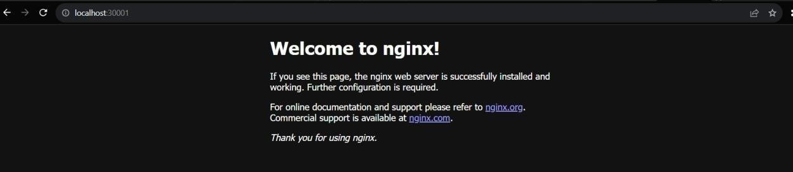

**Task 4: Deleting the Service**

* Delete the service using the following command:

# “ kubectl delete service my-service ”



• Verify that the service has been deleted by running the “ kubectl get services” command.

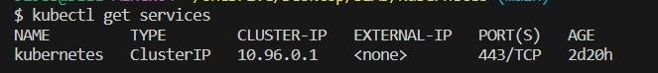

# Task 5: Cleanup

Delete any remaining deployments, services, and resources created during the exercise using the appropriate kubectl delete commands.

# Task 6: Documentation and Best Practices

Document your findings and the best practices for creating and managing services in Kubernetes.

Through this exercise, you'll gain a better understanding of how to create and manage services to expose applications within a Kubernetes cluster. Adjust the exercise based on your specific use case and requirements.